# CSE 4020 - MACHINE LEARNING

# Lab 29+30

# Multi Layer Perceptron

# Submitted by: Alokam Nikhitha(19BCE2555)

**MLP**

**Question:**

To train a Multi-Layer Perceptron (MLP) model to classify the network traffic record whether it is a normal or attack…

1. Read and parse the dataset.

2. Create Multi-Layer Perceptron Model (MLP)

3. Train and evaluate a Multi-Layer Perceptron (MLP) model

**Dataset Used:**

NSL KDD – Intrusion Detection Dataset <https://www.unb.ca/cic/datasets/nsl.html>

**Procedure:**

-Using pandas, we first import the dataset into our workspace.

-Assign the column names to our dataset as it doesn’t have one.

- Pick out and encode our specific variable.

- After encoding the specific variable, we want to dummy encode them on the way to keep away from ordinality among nominal information.

- We then want to re-assign our label information. All labels different than ordinary are assigned as attacks.

- We then want to divide the schooling set and check set information into set of structured attributes and impartial attributes.

- Next, we lay down the Multi-Layer Perceptron and byskip our enter records into enter layer of our neural network.

- Finally, we generate our check set consequences and evaluation metrices.

**Code Snippets and Explanation:**

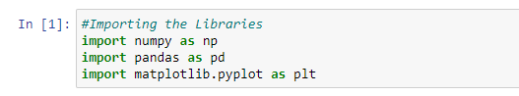

Here we are importing the necessary libraries in our workspace.

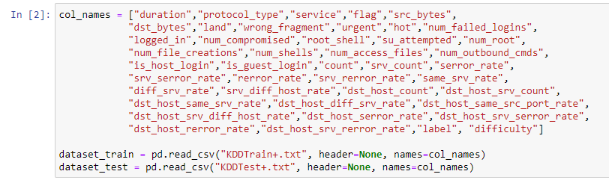

Here we're uploading the dataset into our workspace and are assigning them with the column names because it isn't always pre-blanketed in the given dataset.

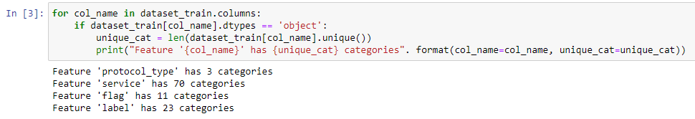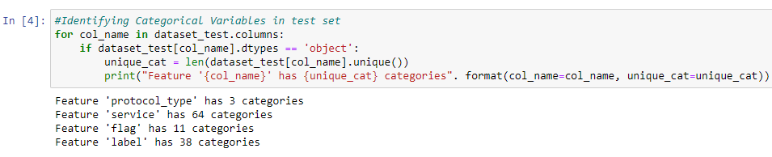

Here we've identified all of the express attributes in our training set and take a look at set. We have additionally identified the range of classes inculcating inside every attribute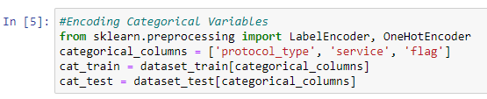

Here we have created 2 dummy data frames to include the categorical attributes in them

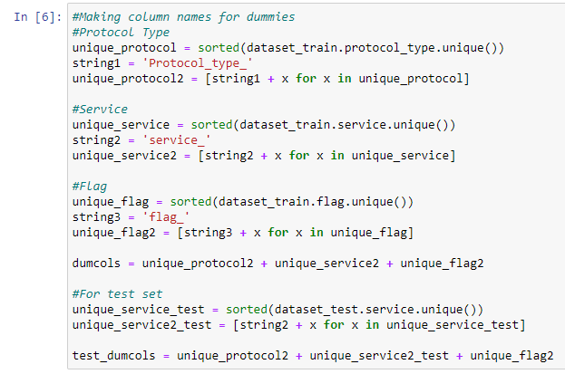

Here we've created the dummy attributes to keep away from the ordinal introduction among those nominal specific attributes.

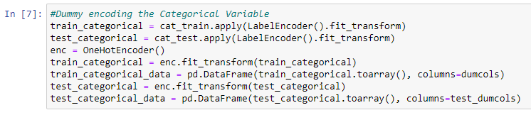

Here we've used the label encoder to fill withinside the dummy attributes in every of the specific attributes.

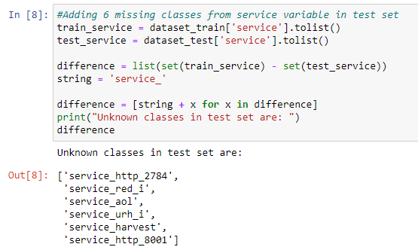

While checking the specific variables we noticed that service characteristic in check set has 70 training whilst schooling set has sixty four training. Hence, we want to encompass the ones 6 dummy attributes with zero fee in every our schooling set. This is what we've got diagnosed and achieved here.

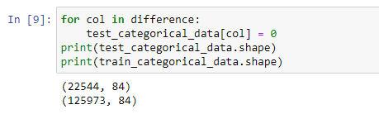

Here we have finalised our data frames with the dummy values of categorical attributes.

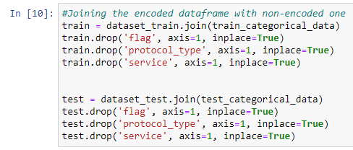

Next, we've got combined our original dataset with dummy attributes that we acquired in our specific assignment. Also right here we've got dropped the original specific attributes for you to inculcate only the non-specific attributes.

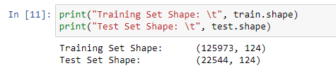

Here we have checked the number of attributes in both the training set and test set to see if they are equal… we can see that they have 124 attributes each and hence are compatible.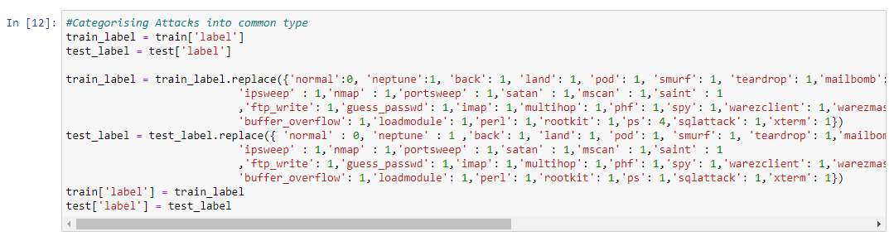

Here we have categorised each of the label attribute either as “normal” or an “attack”. All the labels which are normal are given a label of 0 and all those that indicate an attack are labelled as 1.

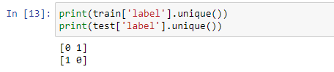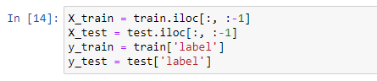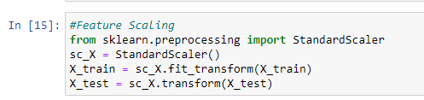

Since all the attributes in our dataset don’t follow a common scale, we need to feature scale the dataset in order to avoid any preassumed weight amongst them. We have used standard scalar to do this and it scales down each attribute to a range in -1 to 1.

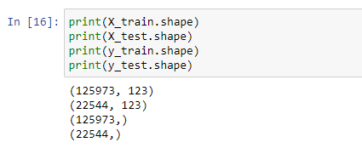

Here we have assigned the set of dependent and independent attributes. Also, we have printed the shape of each category that we have in order to check if they are compatible with each other.

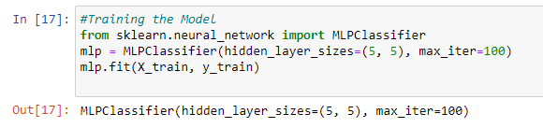

Here we have laid our neural network and then passed our input and output set to it in-order for it to adjust the weight biases.



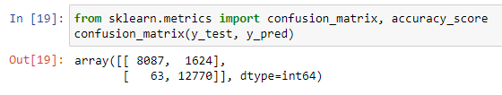

Here we have generated a vector y_pred that stores the result as predicted by our mlp classifier on test set. We have also generated the confusion matrix to check the performance of our classifier.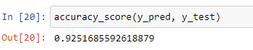

we have printed the accuracy of our model and printed the classification reported to finally check the performance of our model. We can see that the accuracy of the model is 92.51%.

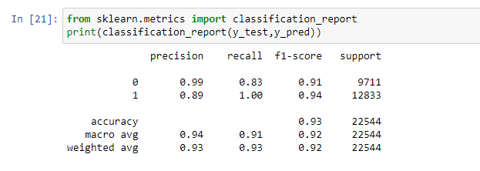

**Result and Conclusion:**

Confusion Matrix:

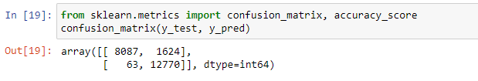

Accuracy:



Accuracy:92.51%.

* Identified Normal = 9711
* Actual Normal = 9362
* Identified Attack = 12833
* Actual Attack = 13182
* True Normal = 8087
* True Attack = 12770
* False Normal = 1624
* False Attack = 63
* Precision Normal = 0.99
* Precision Attack = 0.89
* Recall Normal = 0.83
* Recall Attack = 1.00